# Problem Solving:

**Software requirement:**

In general, here are some common requirements and considerations when using video streaming software:

## Internet Connection:

* + You'll need a stable and reasonably fast internet connection to upload your video content to the streaming platform. The exact speed requirements may vary depending on the quality and resolution of your video stream.

## Compatible Devices:

* + Ensure that the devices (cameras, smartphones, computers) you plan to use for streaming are compatible with the streaming software.

## Encoding Software/Hardware:

* + You may need video encoding software or hardware to convert your video source into a format suitable for streaming. Popular choices include OBS (Open Broadcaster Software), XSplit, or hardware encoders like the Teradek VidiU.

## IBM Cloud Account:

* + You'll typically need an IBM Cloud account to access the IBM Cloud Video services. Make sure to create an account and understand their pricing model and terms of use.

## Streaming Key/URL:

* + You'll need the streaming key or URL provided by IBM Cloud Video to connect your streaming software to their platform. This is essential for securely transmitting your video content to their servers.

## Video Source:

* + Ensure that you have a source for your video content, whether it's a camera, computer screen capture, or prerecorded videos.

## Audio Setup:

* + Good audio quality is essential for a successful stream. Make sure your audio equipment (microphones, audio interfaces) is compatible with your streaming setup.

## System Requirements:

* + Ensure that your computer or streaming device meets the system requirements for the streaming software you plan to use.

## Content Delivery Network (CDN):

* + IBM Cloud Video may use a Content Delivery Network to distribute your video content. Make sure to understand how this works and what impact it may have on your streaming.

## Testing:

* + Before going live, it's crucial to test your setup and stream to ensure everything works smoothly.

This includes testing video and audio quality, checking for dropped frames, and verifying the stream's stability.

# Innovation:

## Enhanced Personalization:

* + Leverage AI and machine learning to provide more personalized content recommendations to users. Analyze their viewing habits and preferences to suggest content they are likely to enjoy.

## Interactive Streaming:

* + Enable interactive elements within your streams, such as polls, quizzes, and live Q&A sessions.

This can enhance viewer engagement and make streams more interactive.

## Low-Latency Streaming:

* + Reduce streaming latency for real-time applications, like live sports and gaming. Explore IBM Cloud's low-latency streaming solutions to ensure a more seamless viewer experience**.**

## Live Analytics:

* + Utilize real-time analytics to monitor stream performance, viewer engagement, and user demographics. This data can be invaluable for making informed content decisions and improving the streaming experience**.**

## Multi-Platform Delivery:

* + Ensure your content is accessible on various devices and platforms, such as smartphones,  
    tablets, and smart TVs. Consider adaptive streaming technologies for delivering content at the optimal  
    quality based on the viewer's connection.

## Content Security:

* + Implement robust content protection and security measures to prevent unauthorized access, content piracy, and leaks.

## AI-Driven Content Moderation:

* + Use AI to automatically moderate user-generated content, comments, and chats to maintain a safe and respectful streaming environment**.**

## Integration with Other IBM Services:

* + Integrate Watson Media with other IBM cloud services, such as IBM Watson for AI-driven content analysis and insights, and IBM Cloud Storage for scalable and secure data storage.

## Global Content Delivery:

* + Use IBM Cloud's global network to ensure your content is delivered efficiently and reliably to viewers worldwide.

## Content Archiving and Search:

* + Implement advanced search and indexing capabilities using AI to make it easier for users to find archived content.

## Sustainability Initiatives:

* + Consider sustainable streaming practices, such as optimizing video compression to reduce data usage and carbon emissions.

**DEVELOPMENT PART 1:**

1. **Sign Up for IBM Cloud:** If you haven't already, you'll need to sign up for an IBM Cloud account. You may also need to subscribe to the IBM Cloud Video Streaming service.
2. **Provision Video Streaming Resources:** Once you're signed up and subscribed, provision the necessary resources for video streaming. This typically includes creating channels, setting up streaming endpoints, and configuring your video settings.
3. **Get API Credentials:** You'll need API credentials to interact with IBM Cloud Video Streaming programmatically. These credentials are typically in the form of an API key and API secret.
4. **Choose a Streaming Protocol:** IBM Cloud Video Streaming supports various streaming protocols such as HLS (HTTP Live Streaming) and DASH (Dynamic Adaptive Streaming over HTTP). Choose the protocol that suits your needs and the devices you want to support.
5. **Generate Stream URLs:** Create stream URLs for your content. These URLs will be used to access your video streams. You might need to use the API to generate these URLs dynamically for different content.
6. **Integrate Video Players:** Choose or build a video player that can render the video streams. Popular choices include HTML5 video players, and there might be IBM-specific options or SDKs available.
7. **Secure Your Streams:** If your content is not public, you'll want to implement security measures, like token-based authentication, to ensure that only authorized users can access your streams.
8. **Testing and Quality Assurance:** Before deploying your media streaming solution, thoroughly test it to ensure the quality, compatibility, and security of your streams. Test on various devices and under different network conditions.
9. **Monitoring and Analytics:** Implement monitoring and analytics to keep track of how your streams are performing. IBM Cloud Video Streaming might offer tools or integrations for this purpose.
10. **Scale and Optimize:** As your user base grows, be prepared to scale your resources to accommodate increased demand. Optimize your setup for cost-efficiency and performance.
11. **Documentation and User Support:** Ensure that you have adequate documentation for users and developers to understand how to access and use your streams. Provide customer support if needed.
12. **Content Delivery:** Consider using a Content Delivery Network (CDN) to distribute your video content globally for better performance and lower latency.
13. **Compliance and Copyright:** Ensure that your streaming content complies with copyright and licensing regulations, especially if you're streaming copyrighted material.

## BASIC DEVELOPMENT OF MY PROJECT:

Login into ibm cloud and Goto catalog

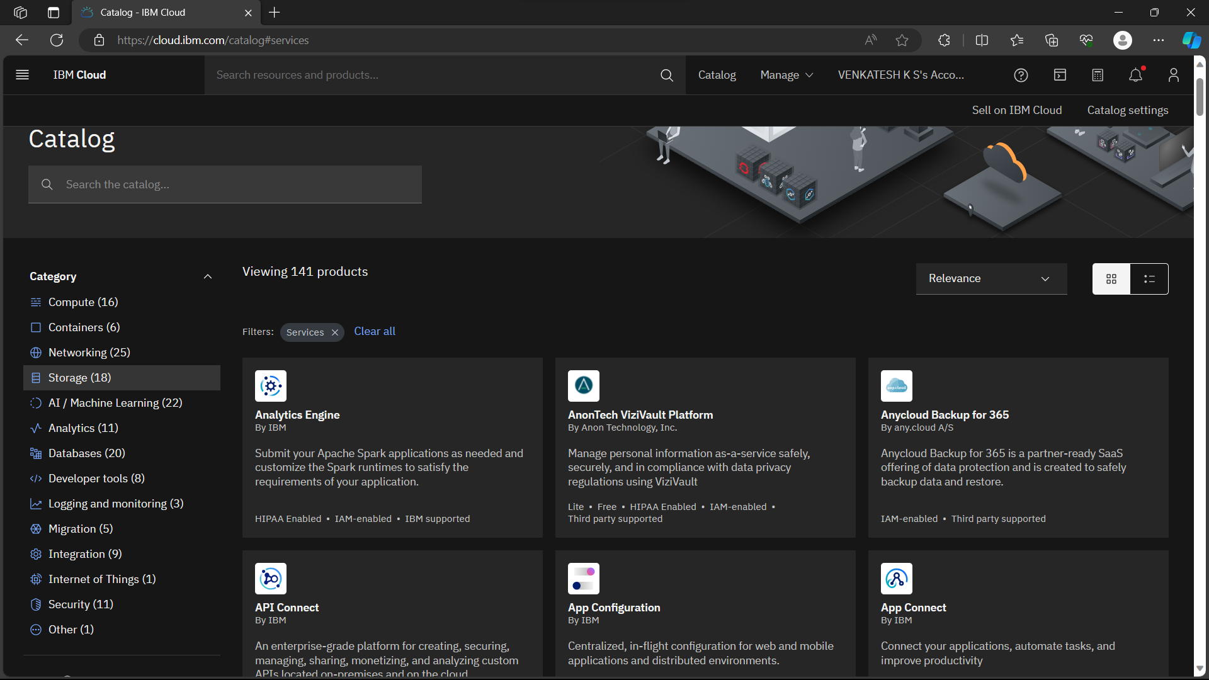

select storage section then click on **object storage**  
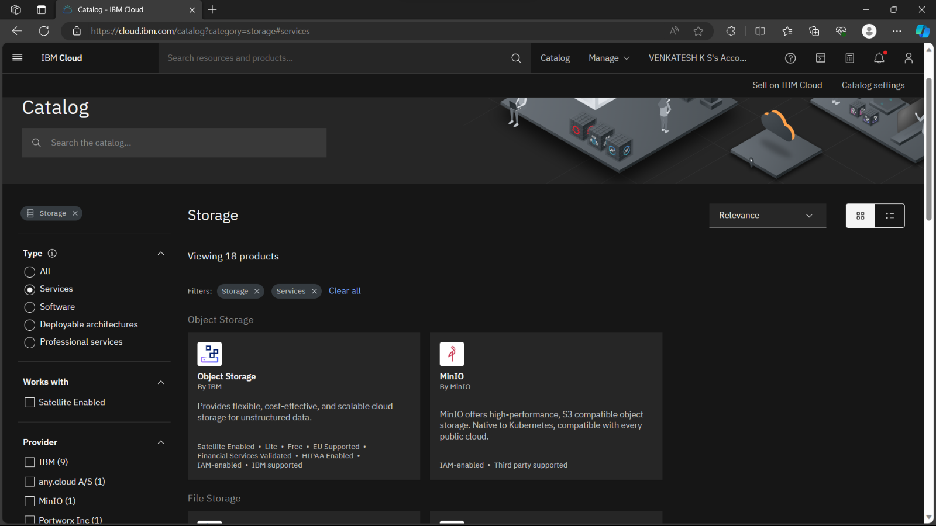

Select free plan and create cloud object storage  
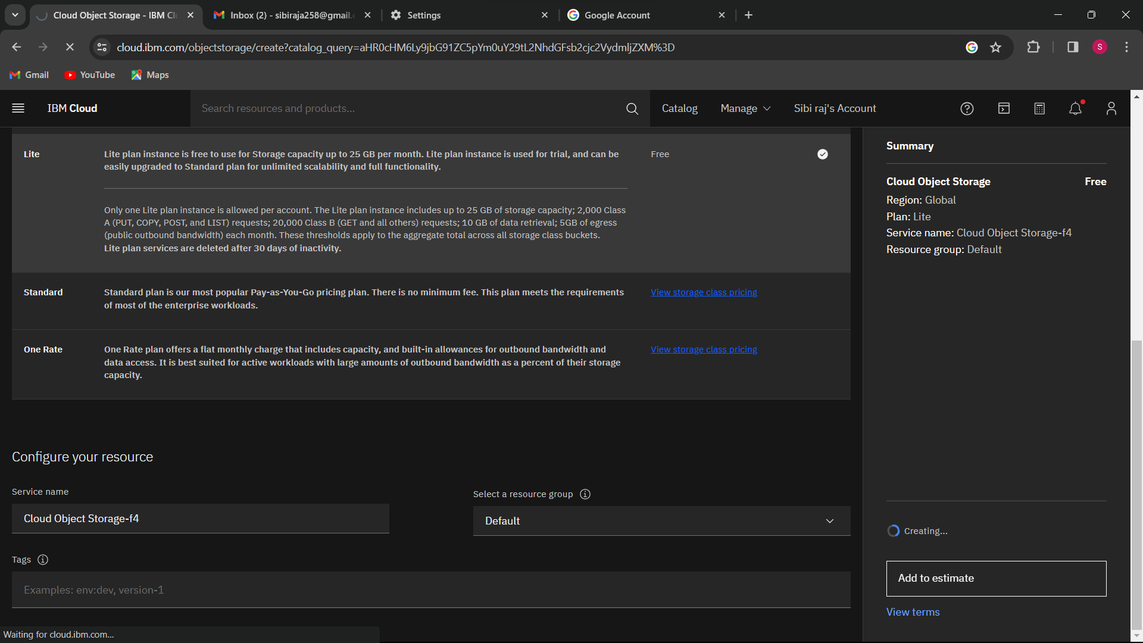  
  
Create bucket  
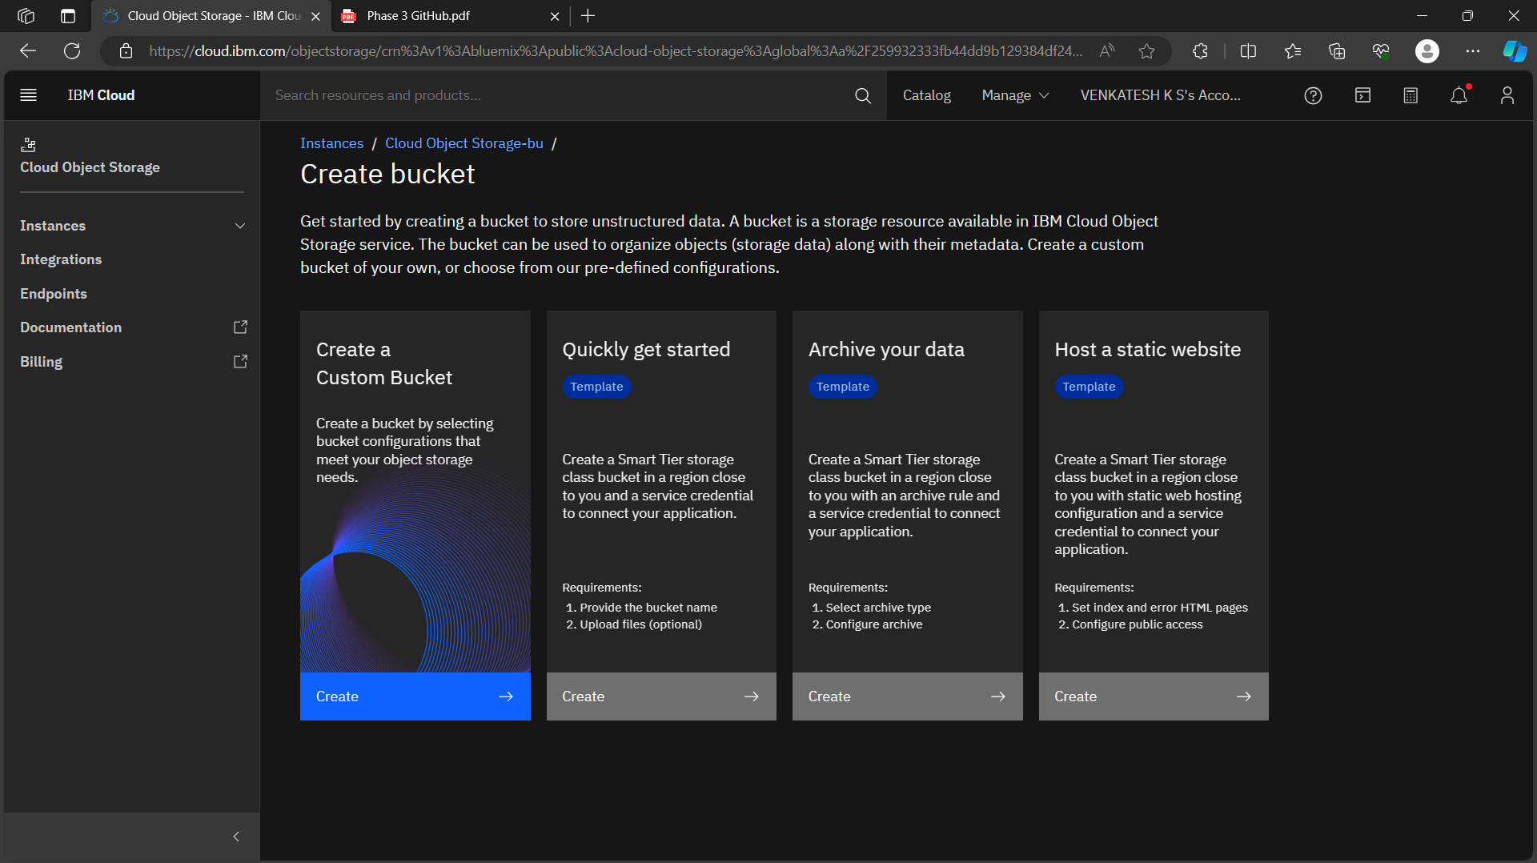

Create a service credentials  
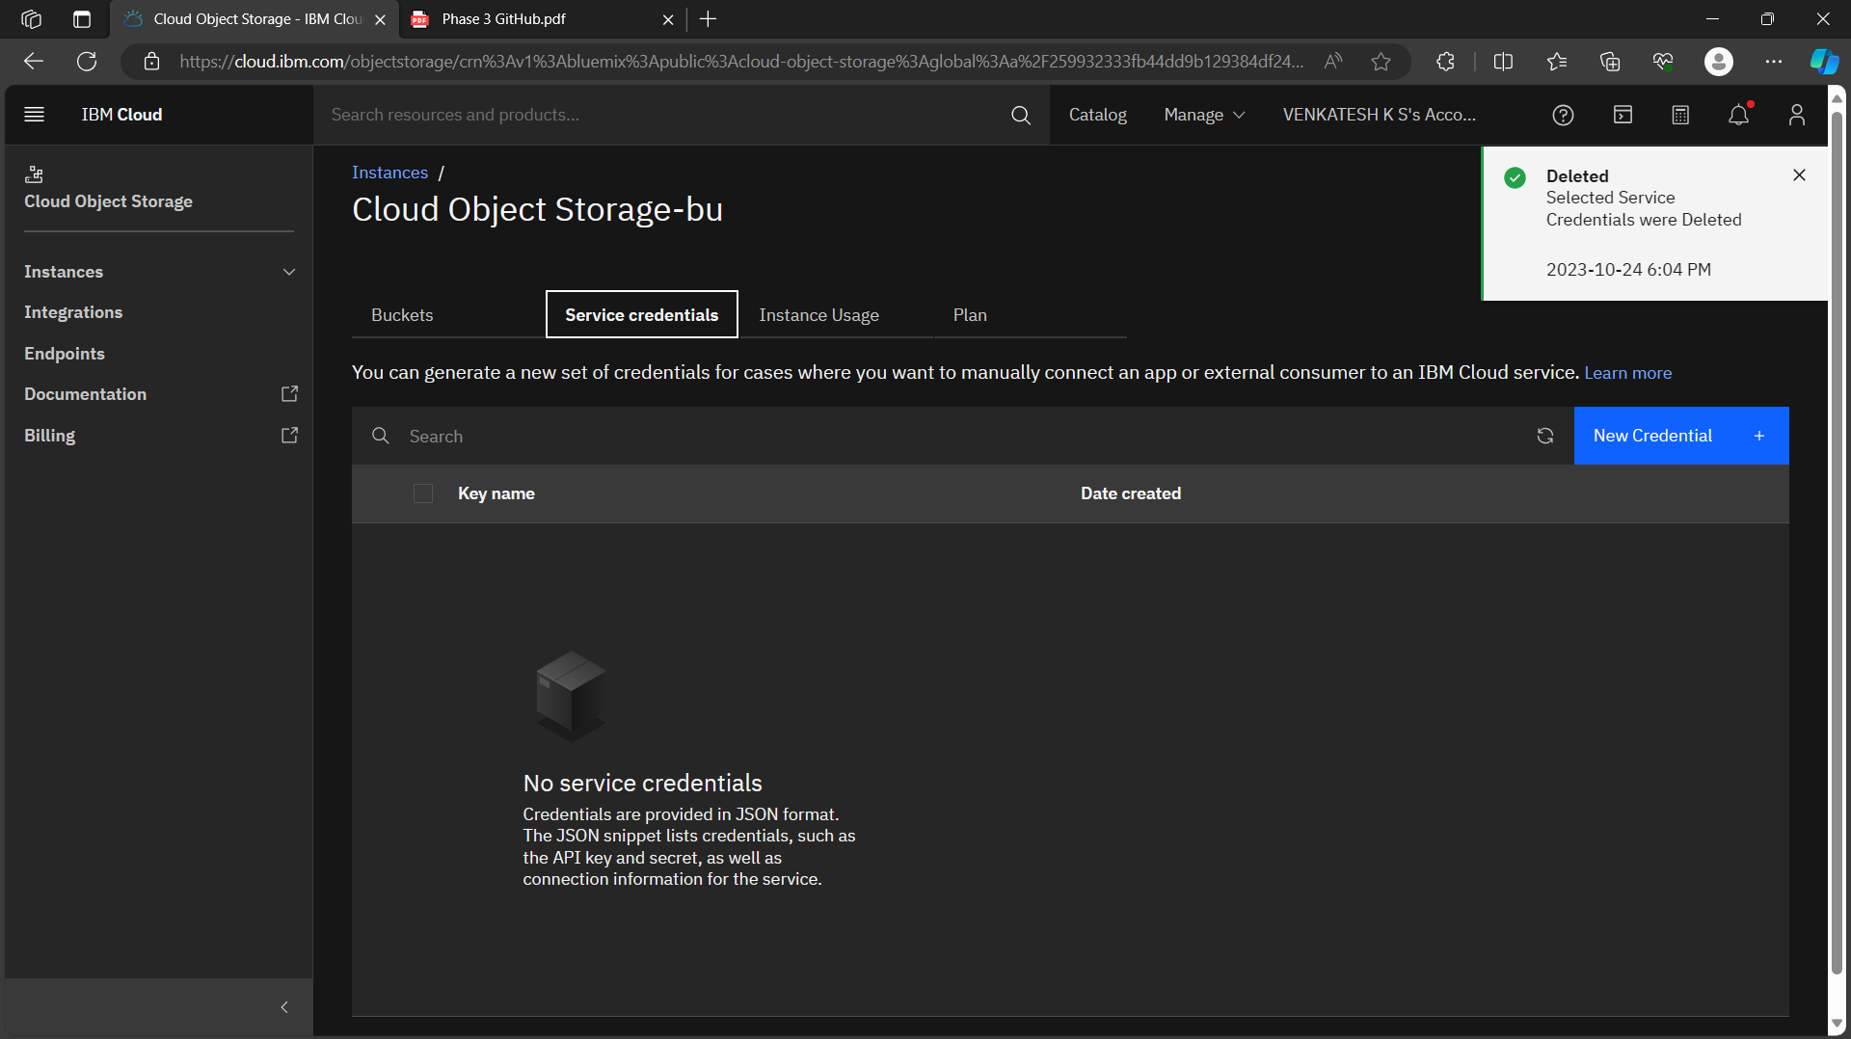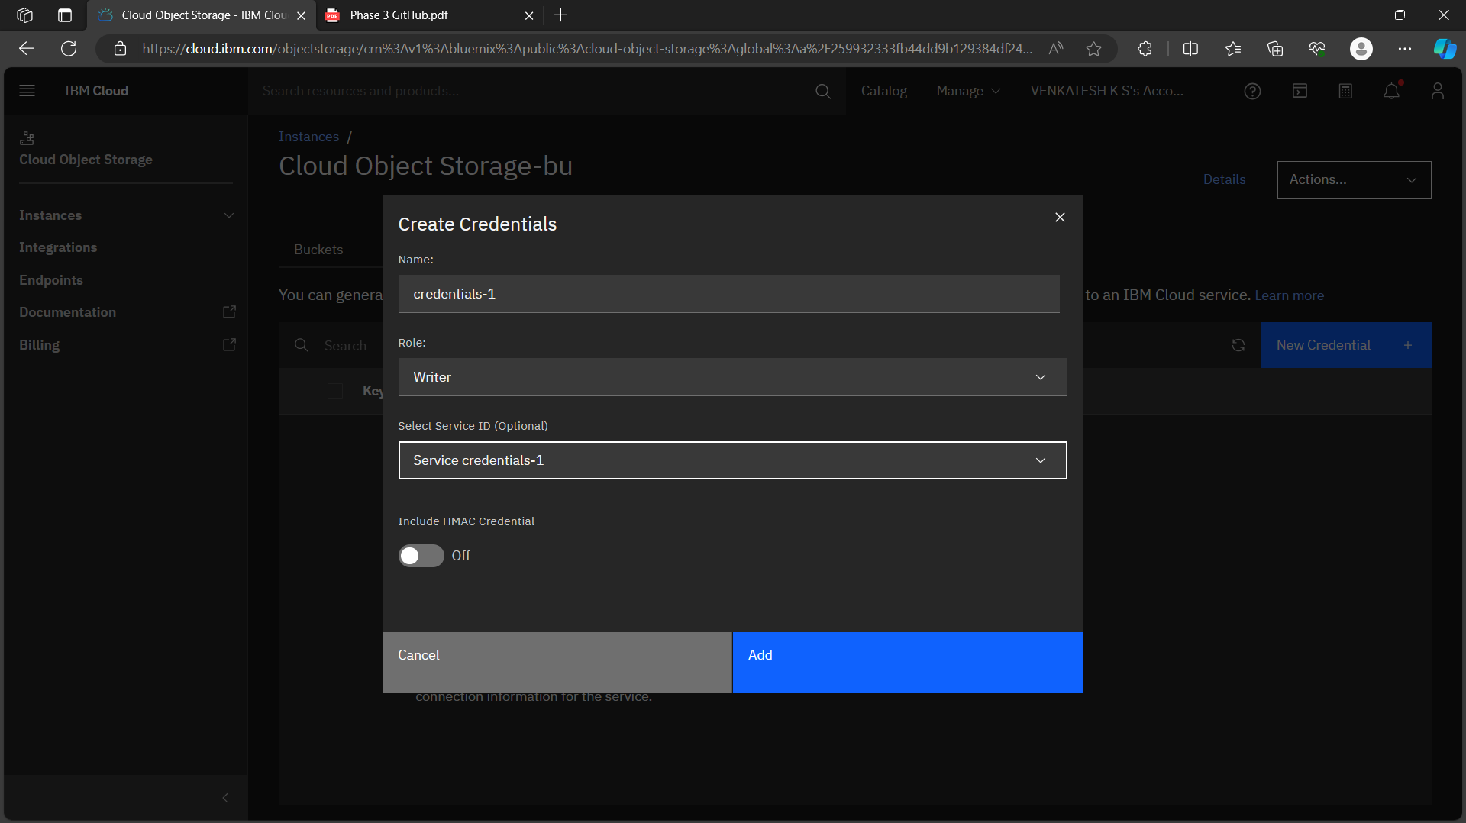

Get the details from service credentials like(apikey, endpoint, apikey name)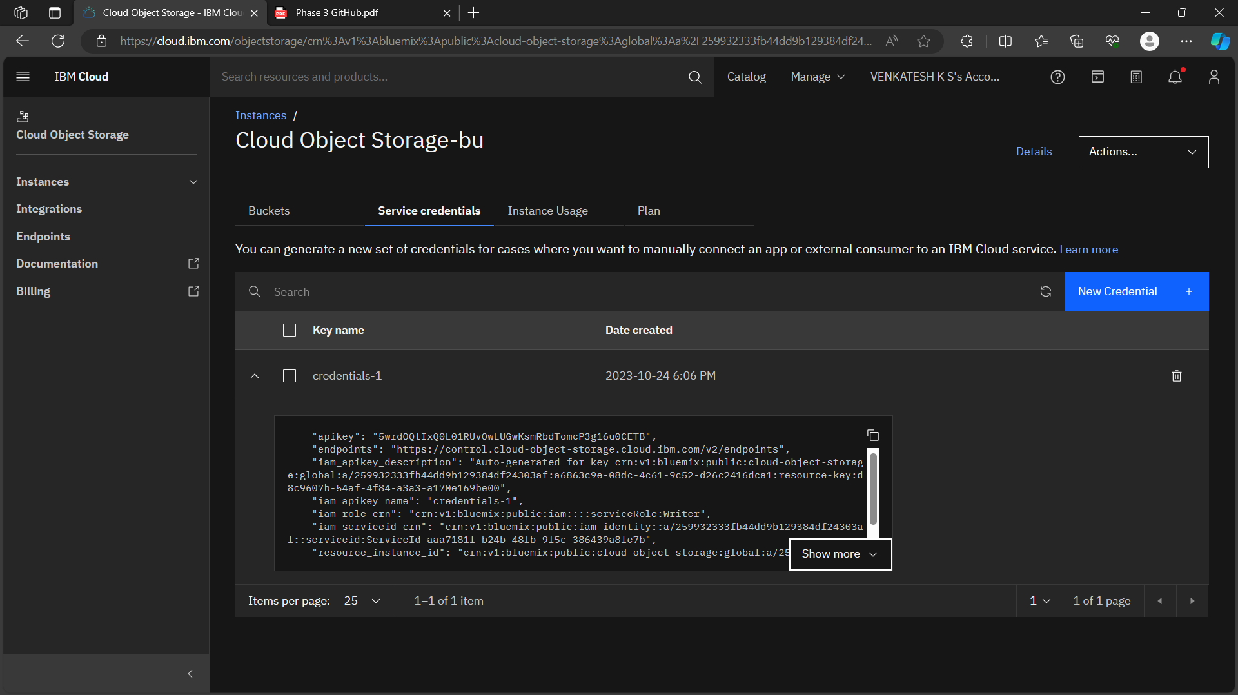

select database section then click on **db2**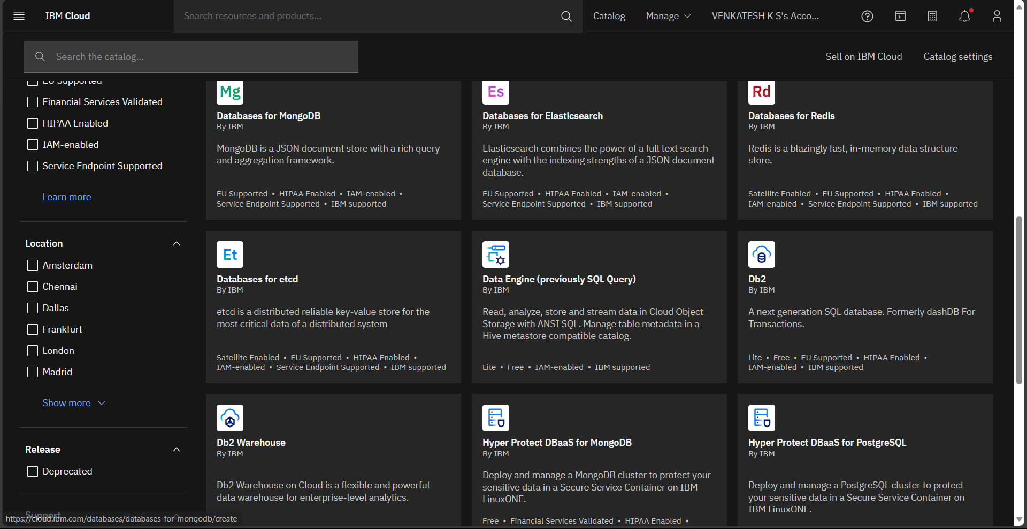

select location **London** and choose free plan then create a **db2**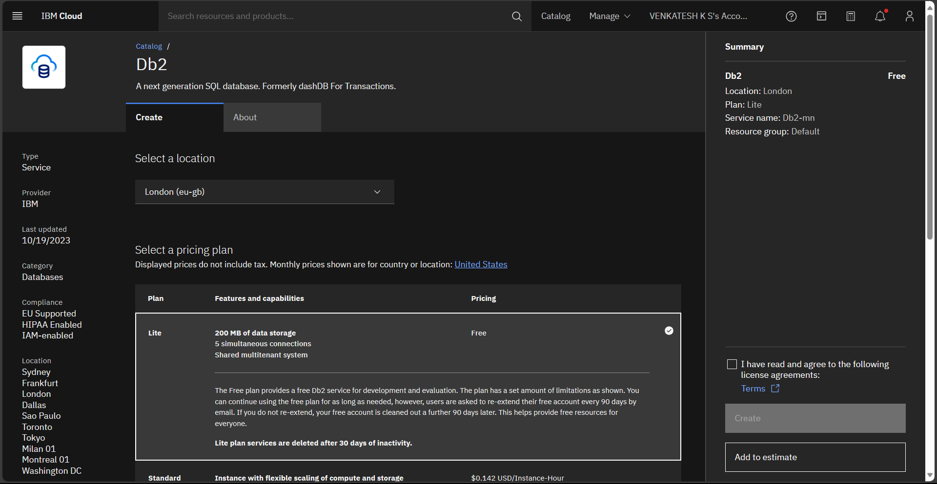then create the service credentials for db2 and get the details like (user name, password, host)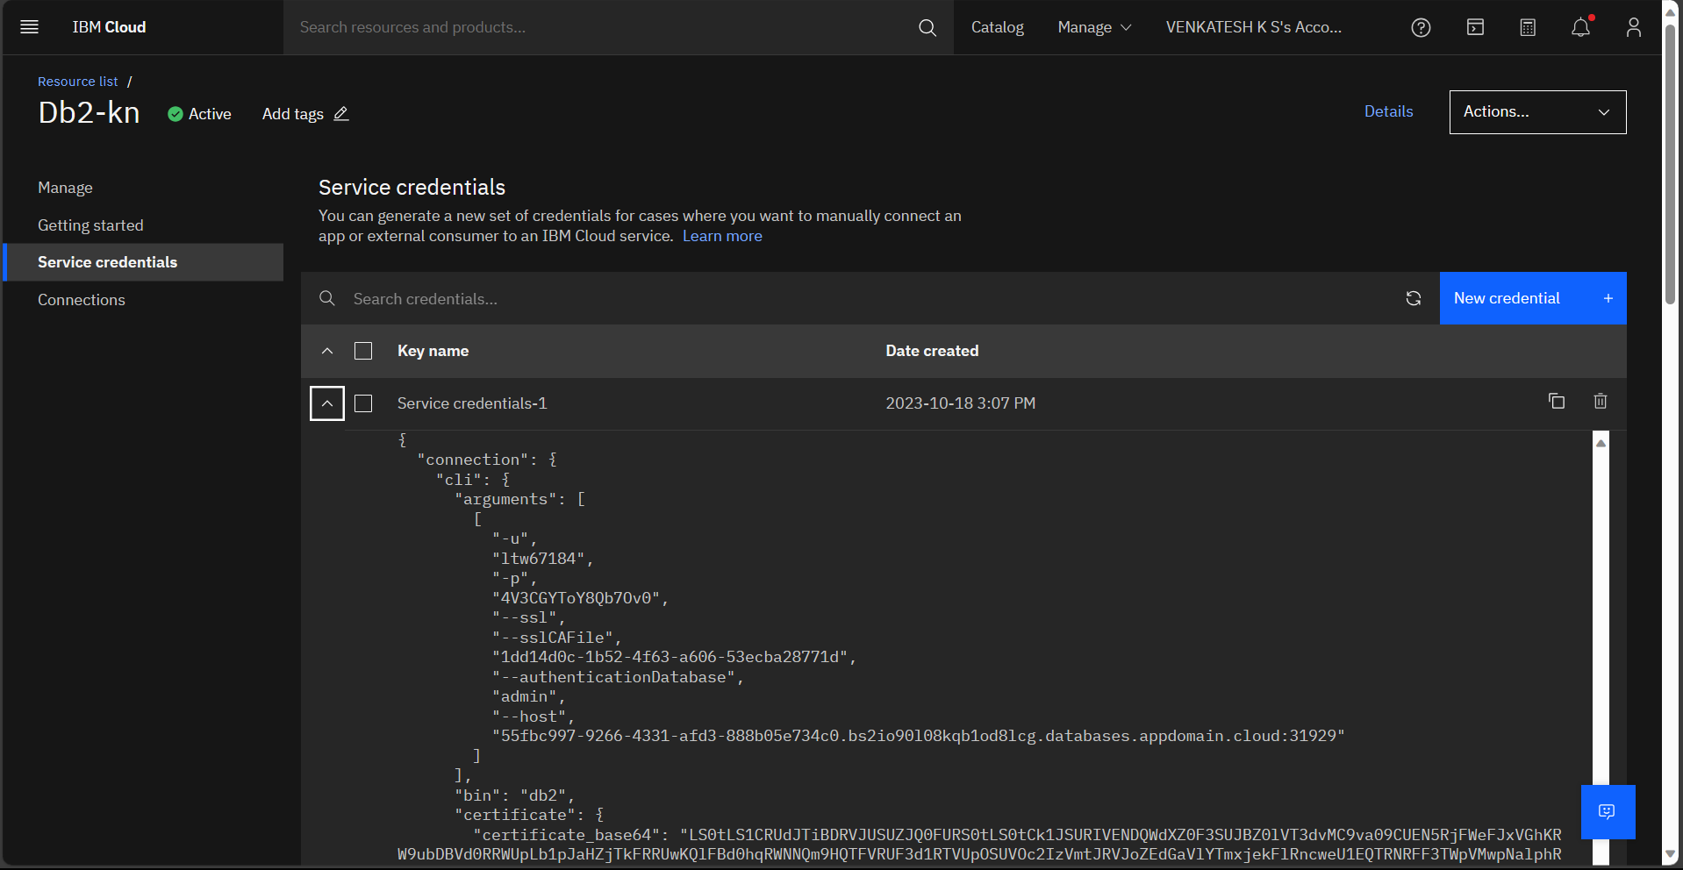

Open command prompt and install **flask** for using flask for backend and **boto3** for using ibm cloud object storage in flash and **ibm-db** for db2 for connect iibm ib2 with flask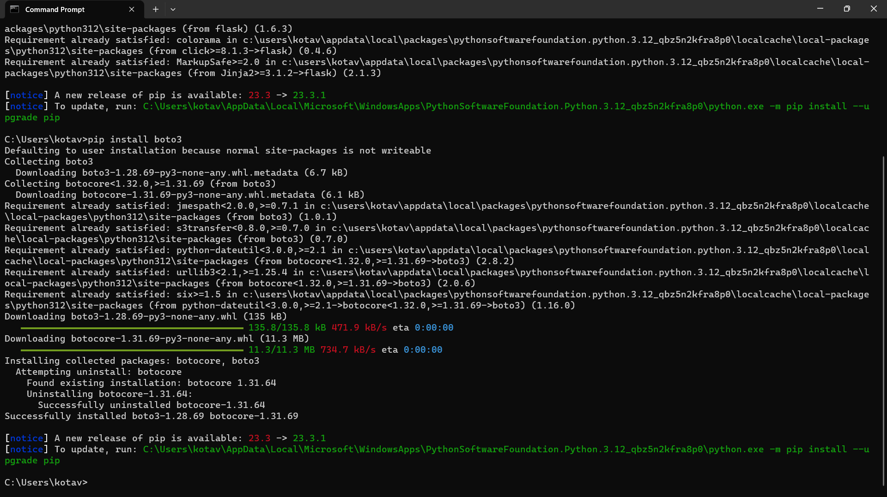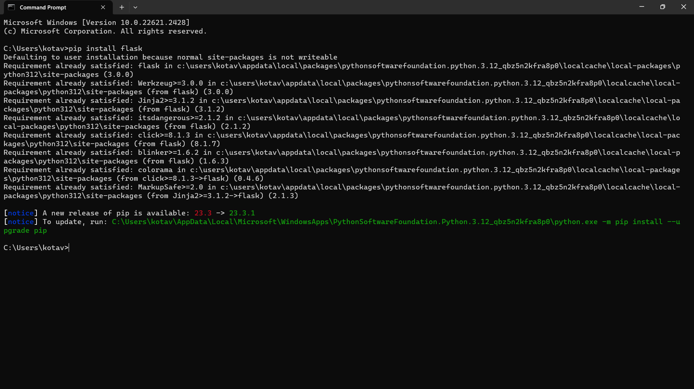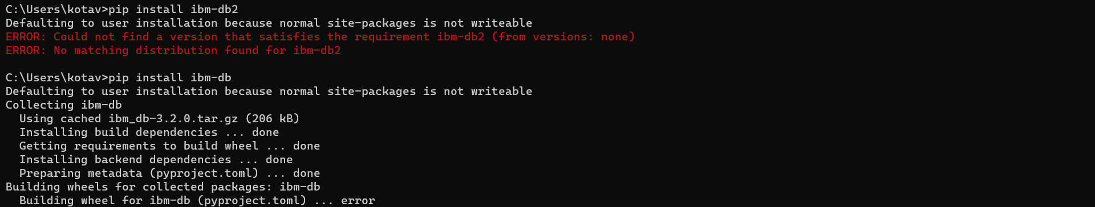

Login page:  
  
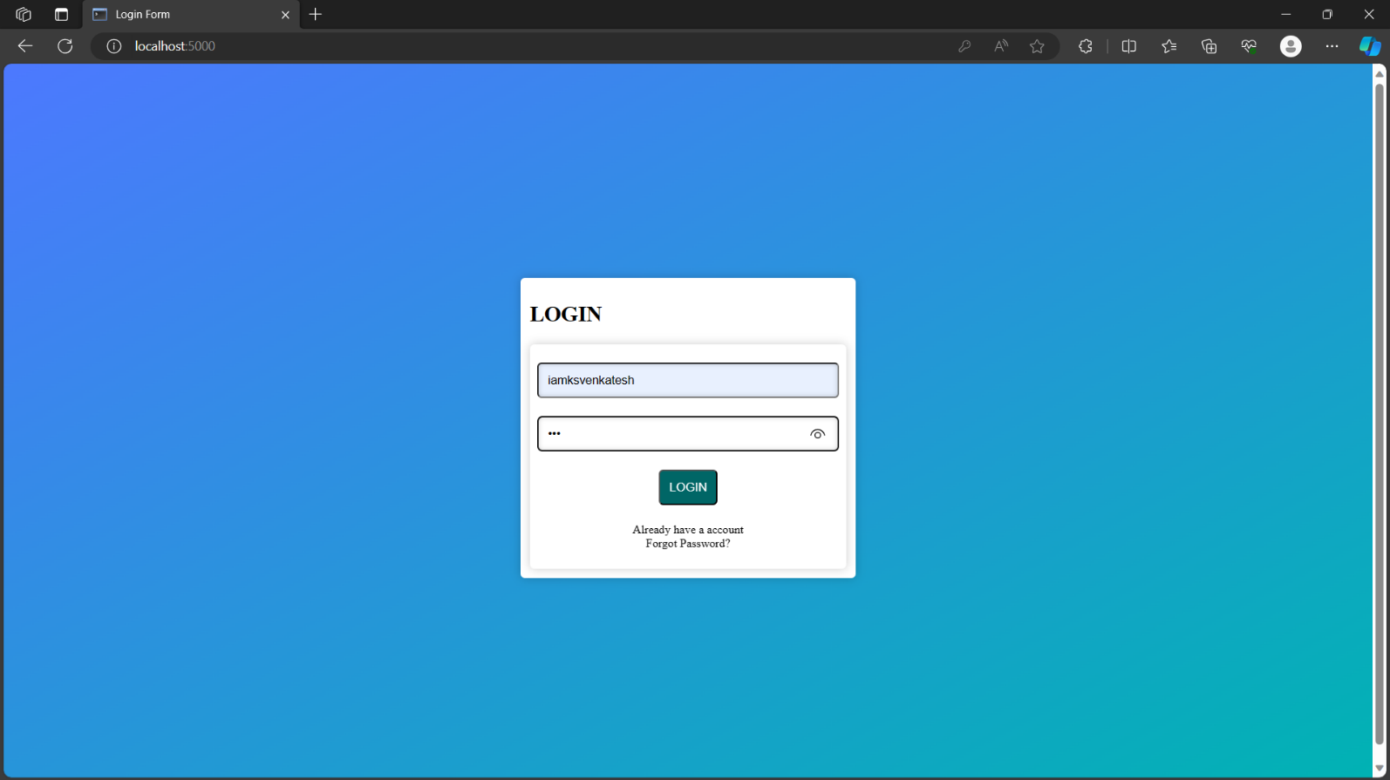

Home page:  
  
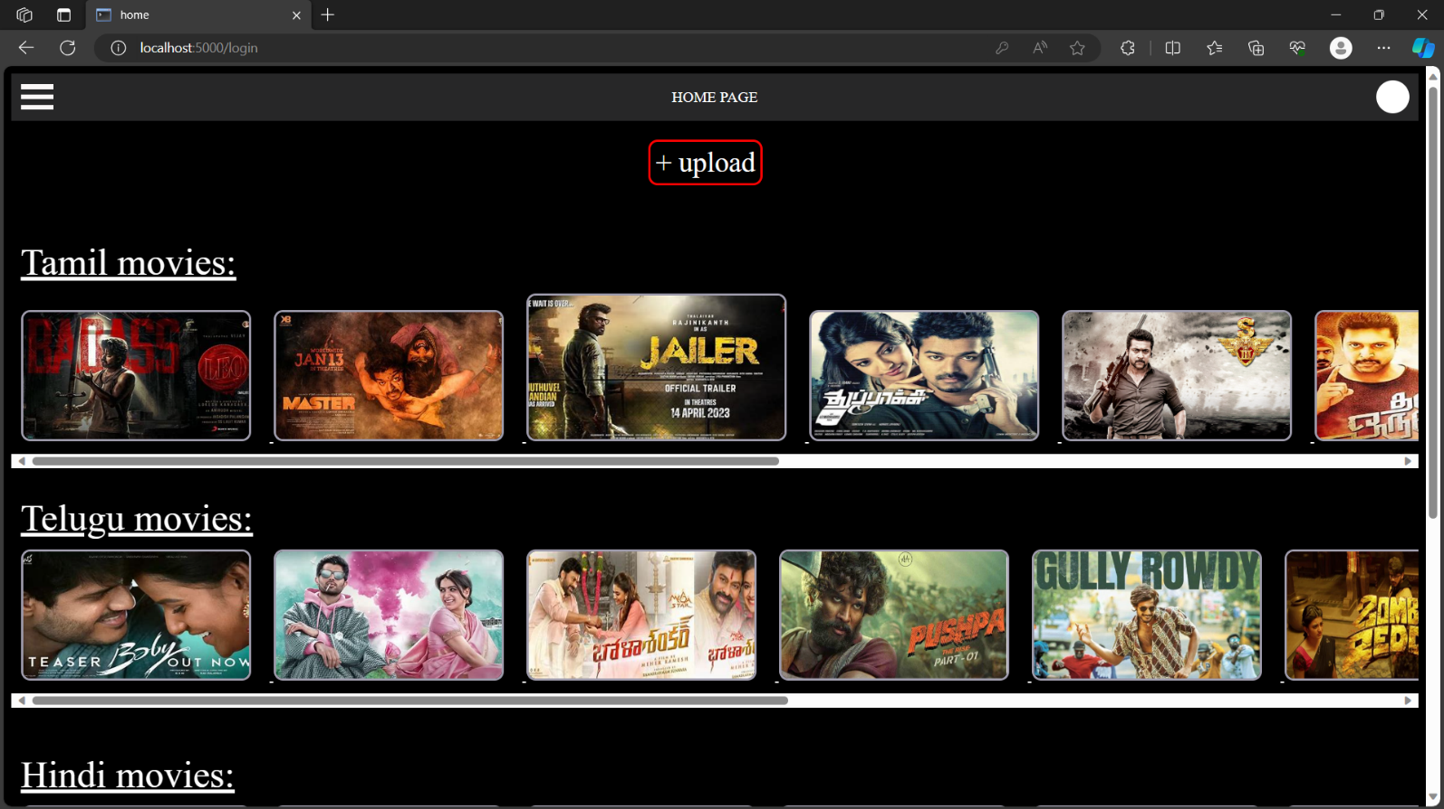

List of some features in home page:  
  
